Assignment 4.4
AI Assisted Coding
Navya Revuri
2303A52483
Question 1:
Task 1:
Prompt: Sentiment Classification for Customer Reviews. An e-commerce platform wants to customer reviews and Classify them into Positive, Negative, or Neutral sentiments Prepare 6 short customer reviews mapped to sentiment labels
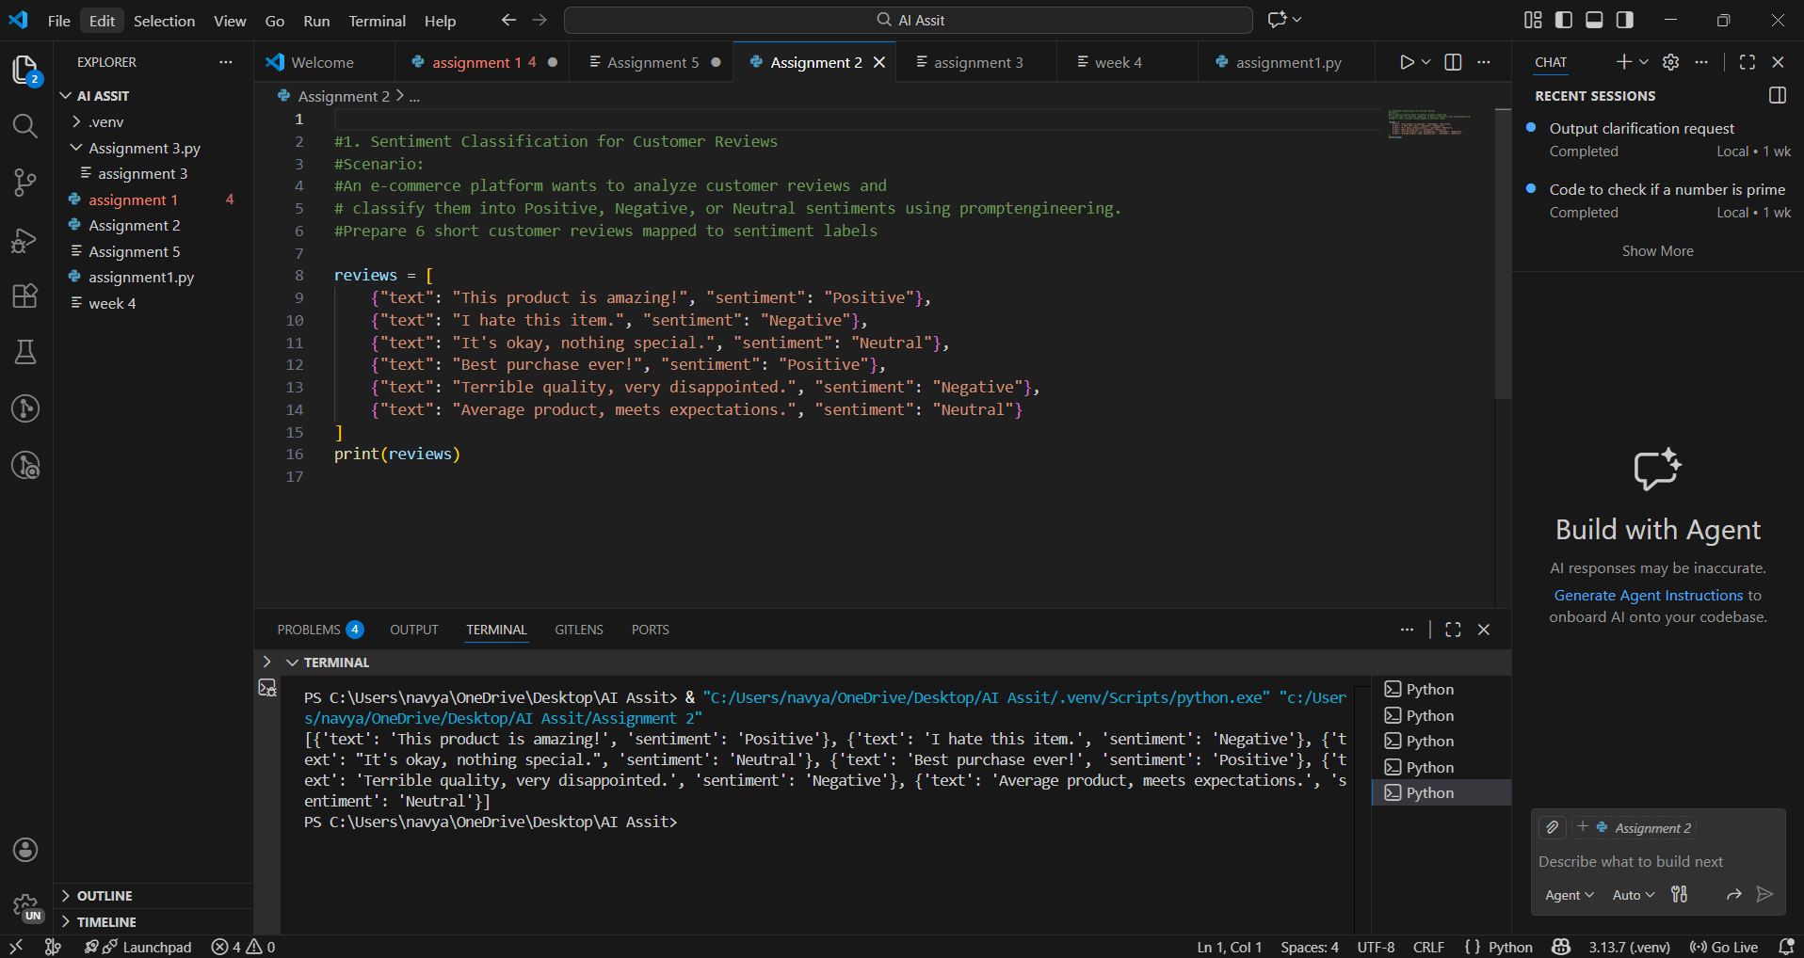Observation:
A list of six customer reviews is created using dictionaries, where each review contains the review text and its corresponding sentiment label (Positive, Negative, or Neutral). This dataset is used as reference output to check whether the prompt-based sentiment classification works correctly.
Task 2:
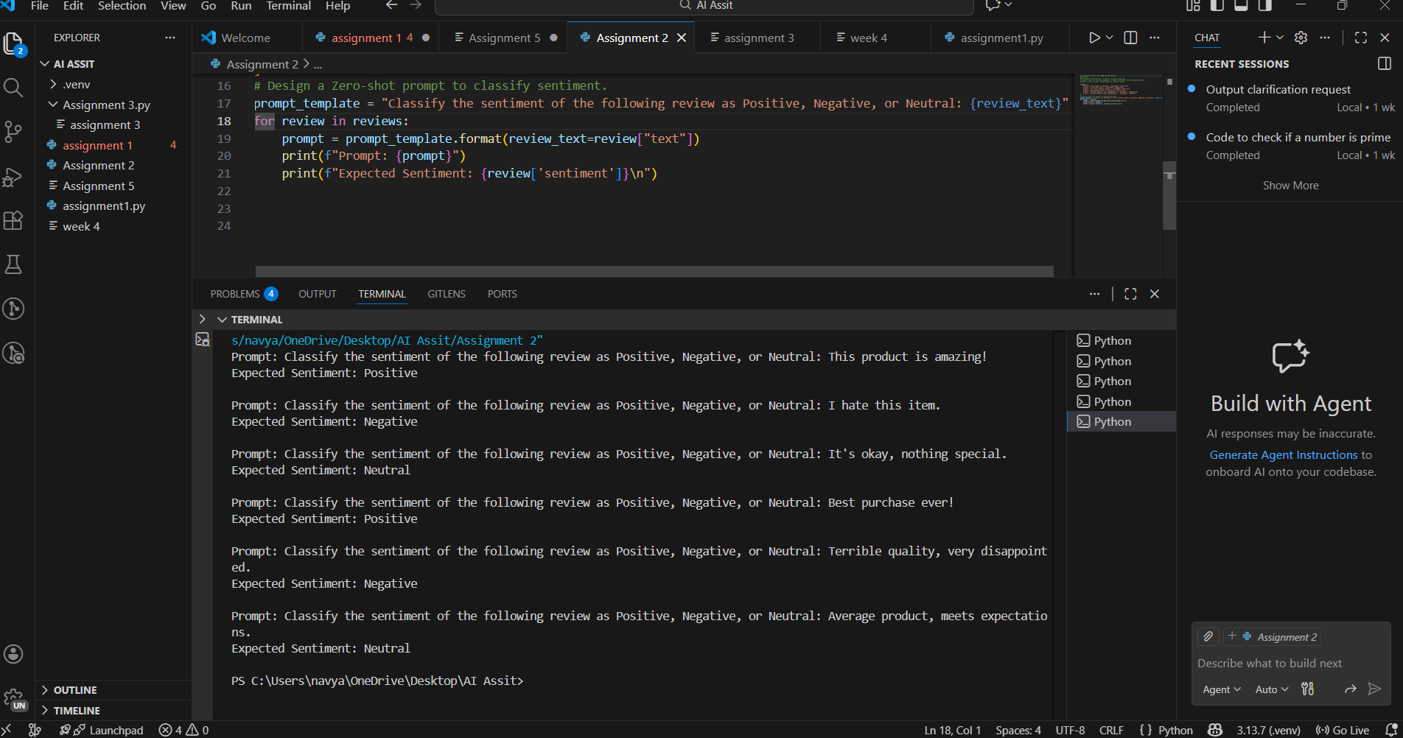
Observation:
In the zero-shot prompting approach, the model is asked to classify the sentiment without providing any example. The prompt directly instructs the model to identify the sentiment from the review text. This method relies entirely on the model’s general understanding of language and sentiment, so accuracy may vary for ambiguous reviews.
Task 3:
Prompt: Classify the sentiment of the following review as Positive, Negative, or Neutral: {review text} \n \ n Example: This product is amazing! -> Positive"

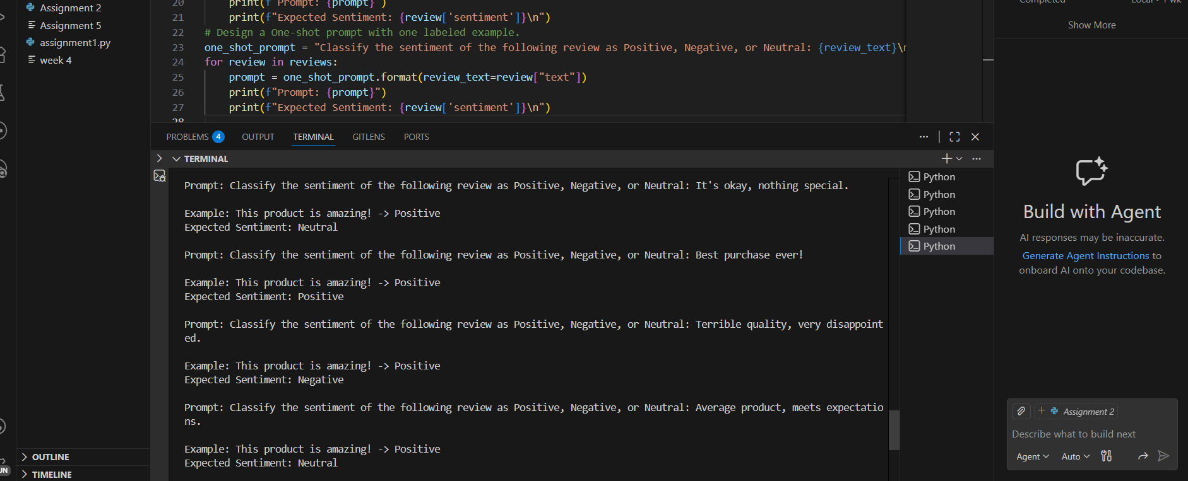
Observation:
In the one-shot prompting approach, one example is included in the prompt before the actual review. This example helps guide the model by showing how a review maps to a sentiment label. Compared to zero-shot prompting, this method generally improves classification accuracy.
Task 4:
Prompt: Classify the sentiment of the following review as Positive, Negative, or Neutral:" \Example: This product is amazing! -> Positive\n Example: I hate this item. -> Negative\n Example: " \"It's okay, nothing special. -> Neutral"

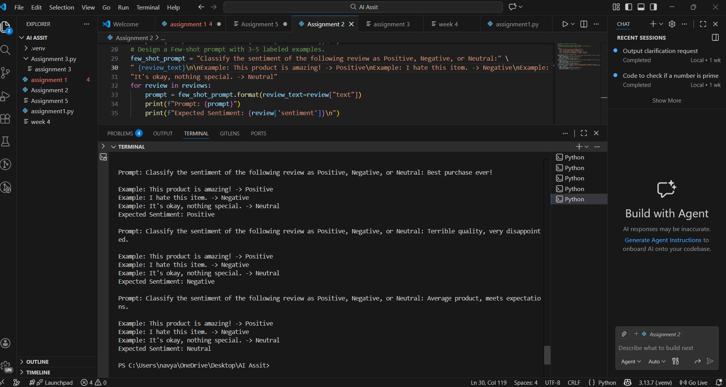
Observation:
In the few-shot prompting approach, multiple examples (Positive, Negative, and Neutral) are provided. These examples help the model learn sentiment patterns more clearly. As a result, few-shot prompting usually produces the most accurate and consistent sentiment classification results.
Task 5:
Comparison of Outputs and Accuracy Differences
- Zero-shot Prompting:
The model classifies sentiment without any examples. While it works well for clearly positive or negative reviews, it may give incorrect results for neutral or mixed-tone reviews. Hence, accuracy is the lowest among the three methods.
- One-shot Prompting:
The model is given one example, which helps it understand how sentiments are mapped. This improves accuracy compared to zero-shot prompting, but performance can still vary if the review style differs from the example.
- Few-shot Prompting:
Multiple examples are provided, covering Positive, Negative, and Neutral sentiments. This gives the model a better understanding of sentiment patterns, resulting in the highest accuracy and more consistent outputs.
Question 2:
Task 1:
#A company wants to automatically prioritize incoming emails into High Priority, Medium Priority, or Low Priority.#Create 6 sample email messages with priority labels.

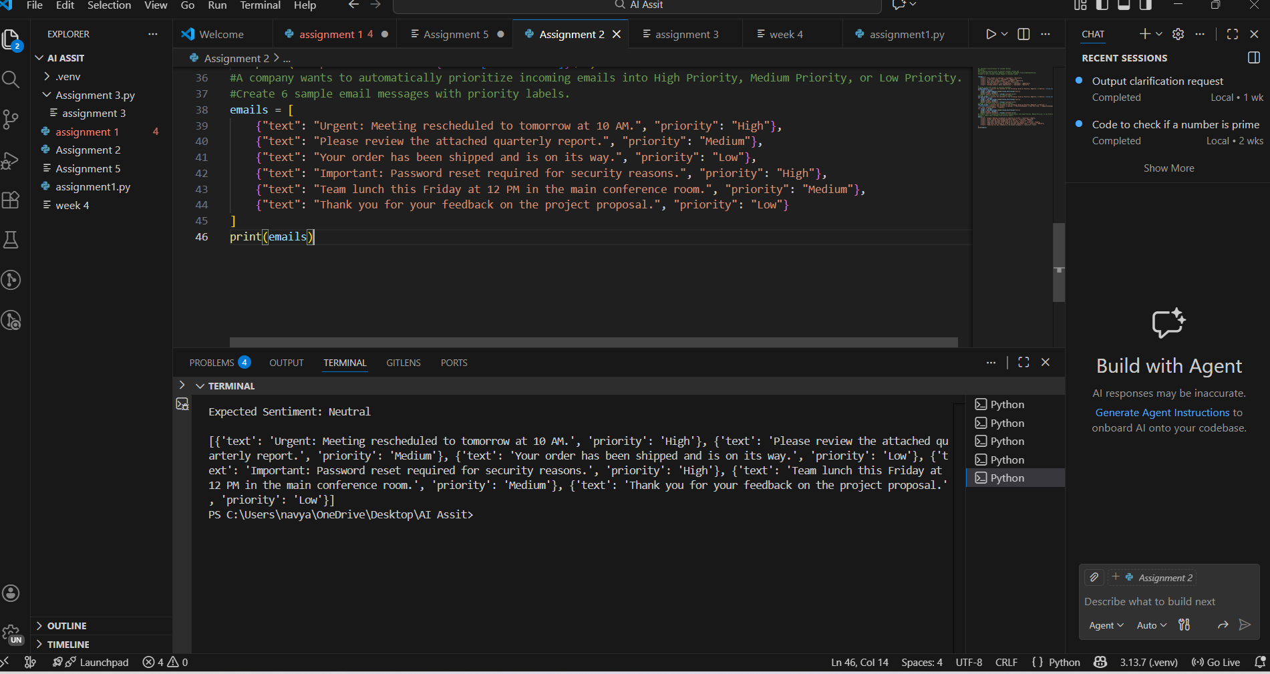
Observation:
A list of six email messages is created, where each email contains the email text and its corresponding priority level (High, Medium, or Low). This dataset is used as the ground truth to evaluate the effectiveness of different prompt-based email priority classification techniques.
Task 2:
Prompt = "Classify the priority of the following email as High, Medium, or Low:

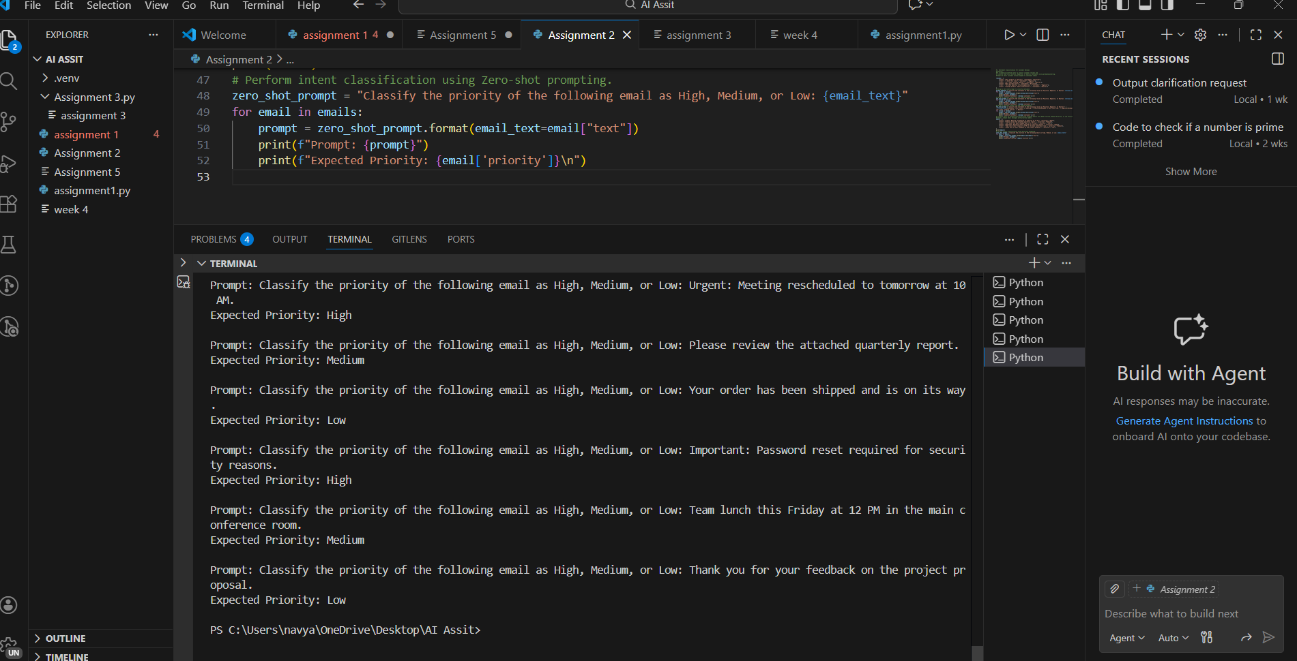
Observation:
In zero-shot prompting, the model is asked to classify the email priority without any example. The model relies only on its general understanding of urgency and intent. This method works well for clearly urgent emails but may misclassify emails with moderate or low urgency, resulting in lower accuracy.
Task 3:
Prompt: Classify the priority of the following email as High, Medium, or Low: {email text} \n \n Example: Urgent: Meeting rescheduled to tomorrow at 10 AM. -> High"
for email in emails:
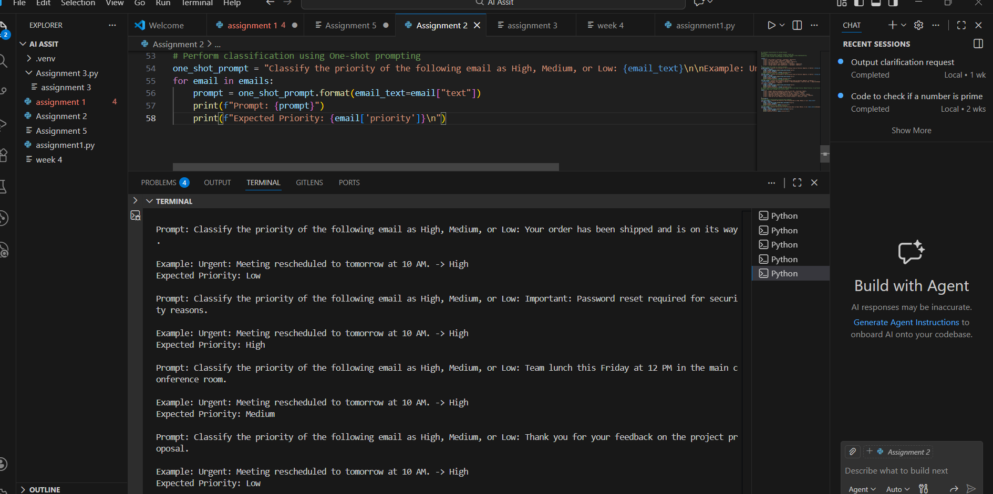
Observation:
In one-shot prompting, a single example is provided along with the input email. This example helps guide the model toward the correct interpretation of priority levels. Accuracy is improved compared to zero-shot prompting, but the results still depend on how similar the email is to the given example
Task 4:
Prompt: Classify the priority of the following email as High, Medium, or Low: {email text} \n\n Example: Urgent: Meeting rescheduled to tomorrow at 10 AM. -> High\n Example: Please review the attached quarterly report. -> Medium\n Example: Your order has been shipped and is on its way. -> Low"

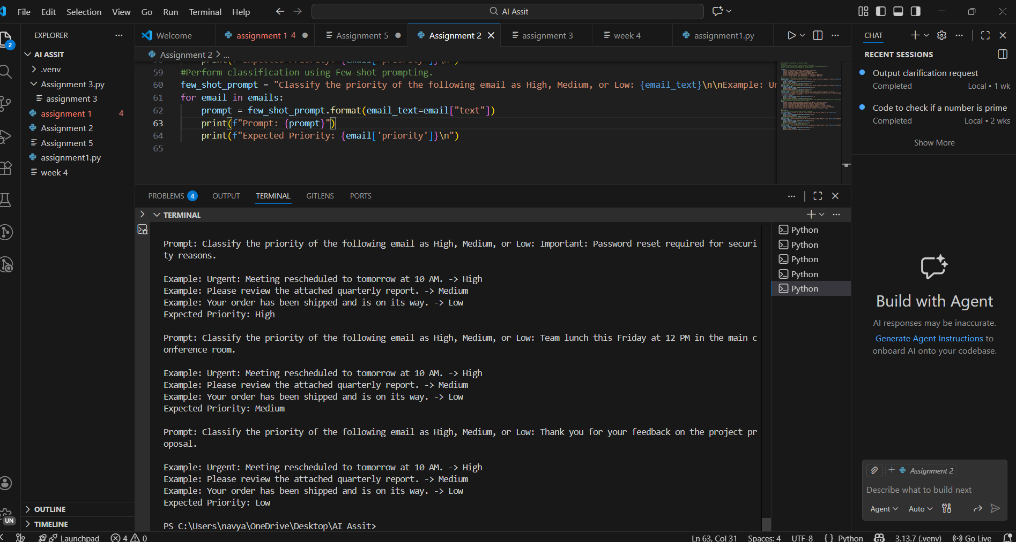
Observation:
In few-shot prompting, multiple examples covering High, Medium, and Low priorities are included. This provides better context and clearer priority patterns for the model. As a result, few-shot prompting produces the most consistent and accurate classification results.
Task 5:
Among Zero-shot, One-shot, and Few-shot prompting techniques, Few-shot prompting produces the most reliable results.
- Zero-shot prompting is the least reliable because no examples are provided, so the model depends only on its general understanding and may misclassify emails with unclear urgency.
- One-shot prompting is more reliable than zero-shot because a single example helps guide the model, but accuracy can still vary if the email differs from the given example.
- Few-shot prompting is the most reliable because multiple examples clearly define High, Medium, and Low priorities, helping the model recognize patterns and reduce ambiguity.
Conclusion
Few-shot prompting gives the highest accuracy and consistency, making it the best technique for email priority classification.
Question 3:
Task 1:
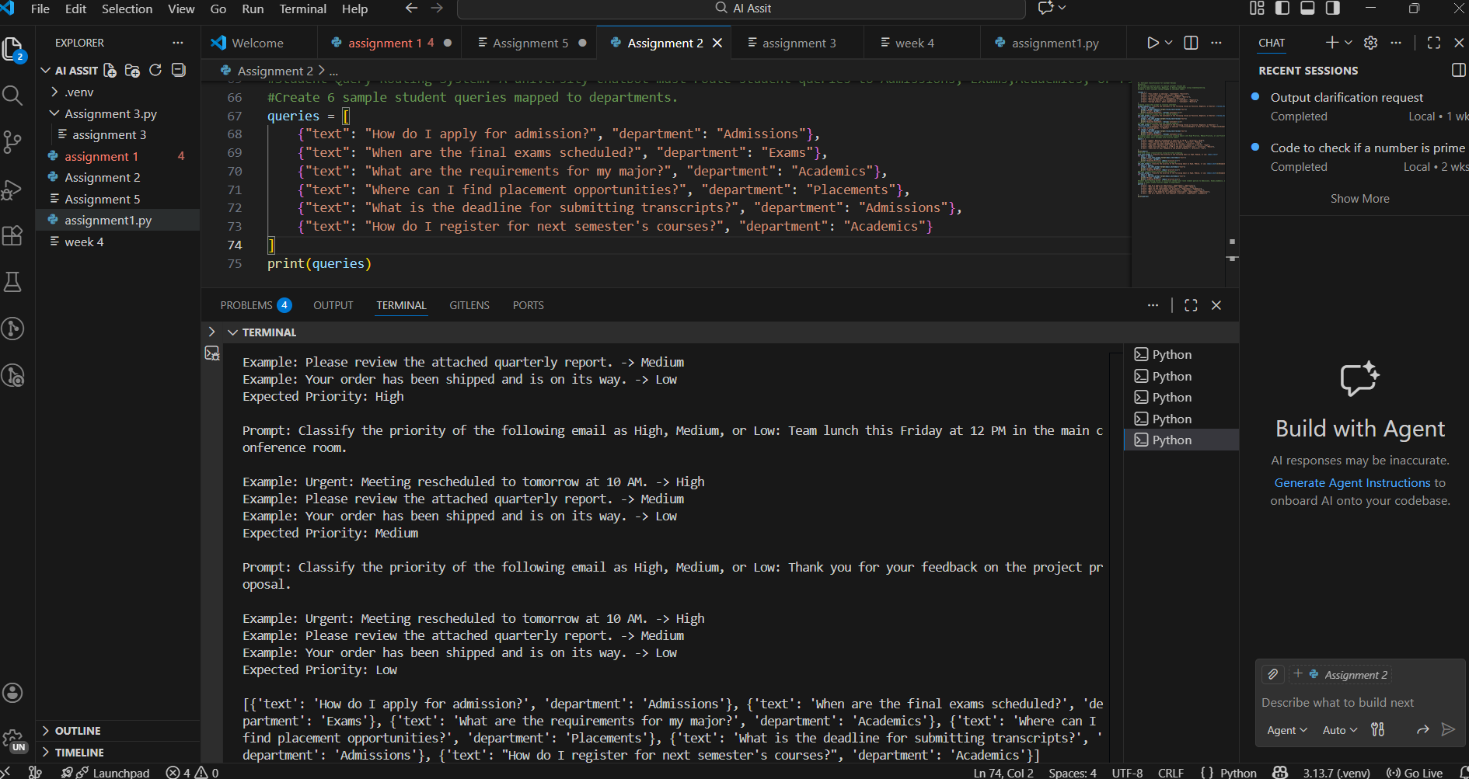
Observation:
A list of six student queries is created, where each query contains the query text and the corresponding department label (Admissions, Exams, Academics, or Placements). This dataset serves as the reference to evaluate the accuracy of intent classification using different prompting techniques.
Task 2:
Prompt: Classify the department of the following student query as Admissions, Exams, Academics, or Placements:
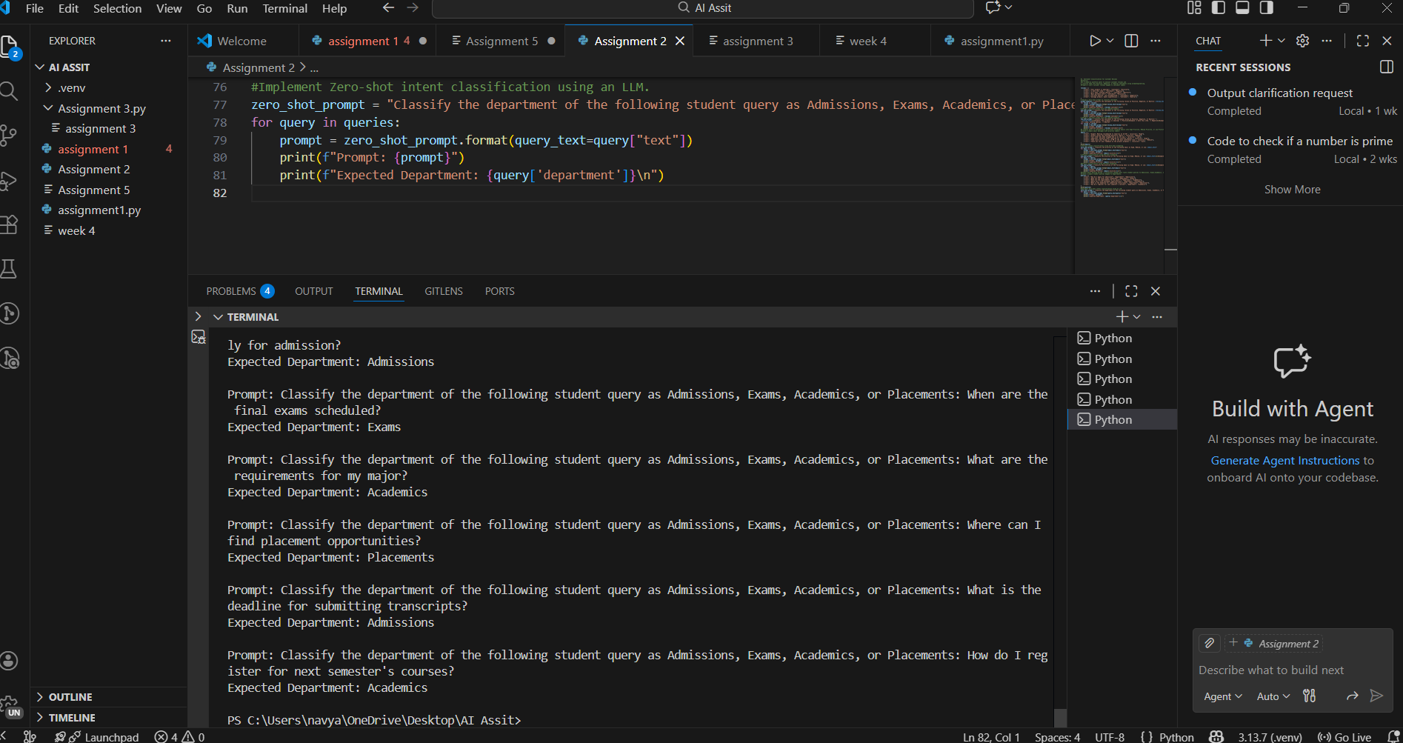
Observation:
In zero-shot prompting, the model is asked to classify the department without any example. The model relies on its general understanding of the query content. This approach works for clear queries but may produce incorrect results for queries that are ambiguous or closely related across departments
Task 3:
Prompt: Classify the department of the following student query as Admissions, Exams, Academics, or Placements: {query text} \n\n Example: How do I apply for admission? -> Admissions"
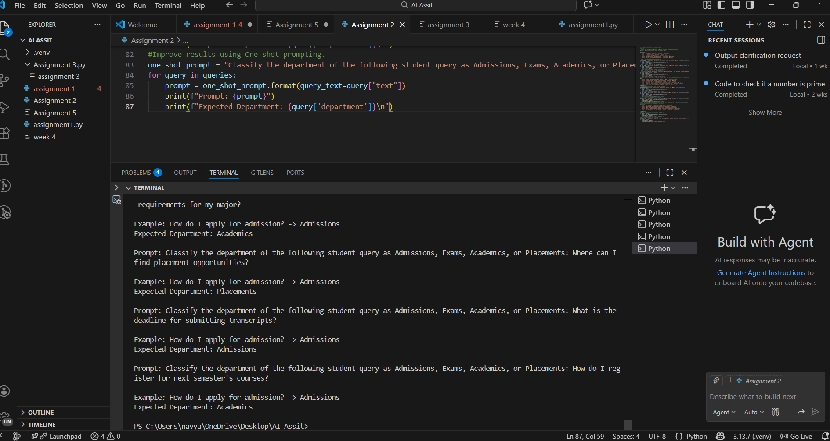
Observation:
In one-shot prompting, one example is provided before the actual query. This example helps guide the model in mapping query intent to the correct department. Accuracy improves compared to zero-shot prompting, but performance still depends on similarity between the example and the query
Task 4:
Prompt: "Classify the department of the following student query as Admissions, Exams, Academics, or Placements: {query text} \n\n Example: How do I apply for admission? -> Admissions\n Example: When are the final exams scheduled? -> Exams\n Example: What are the requirements for my major? -> Academics"
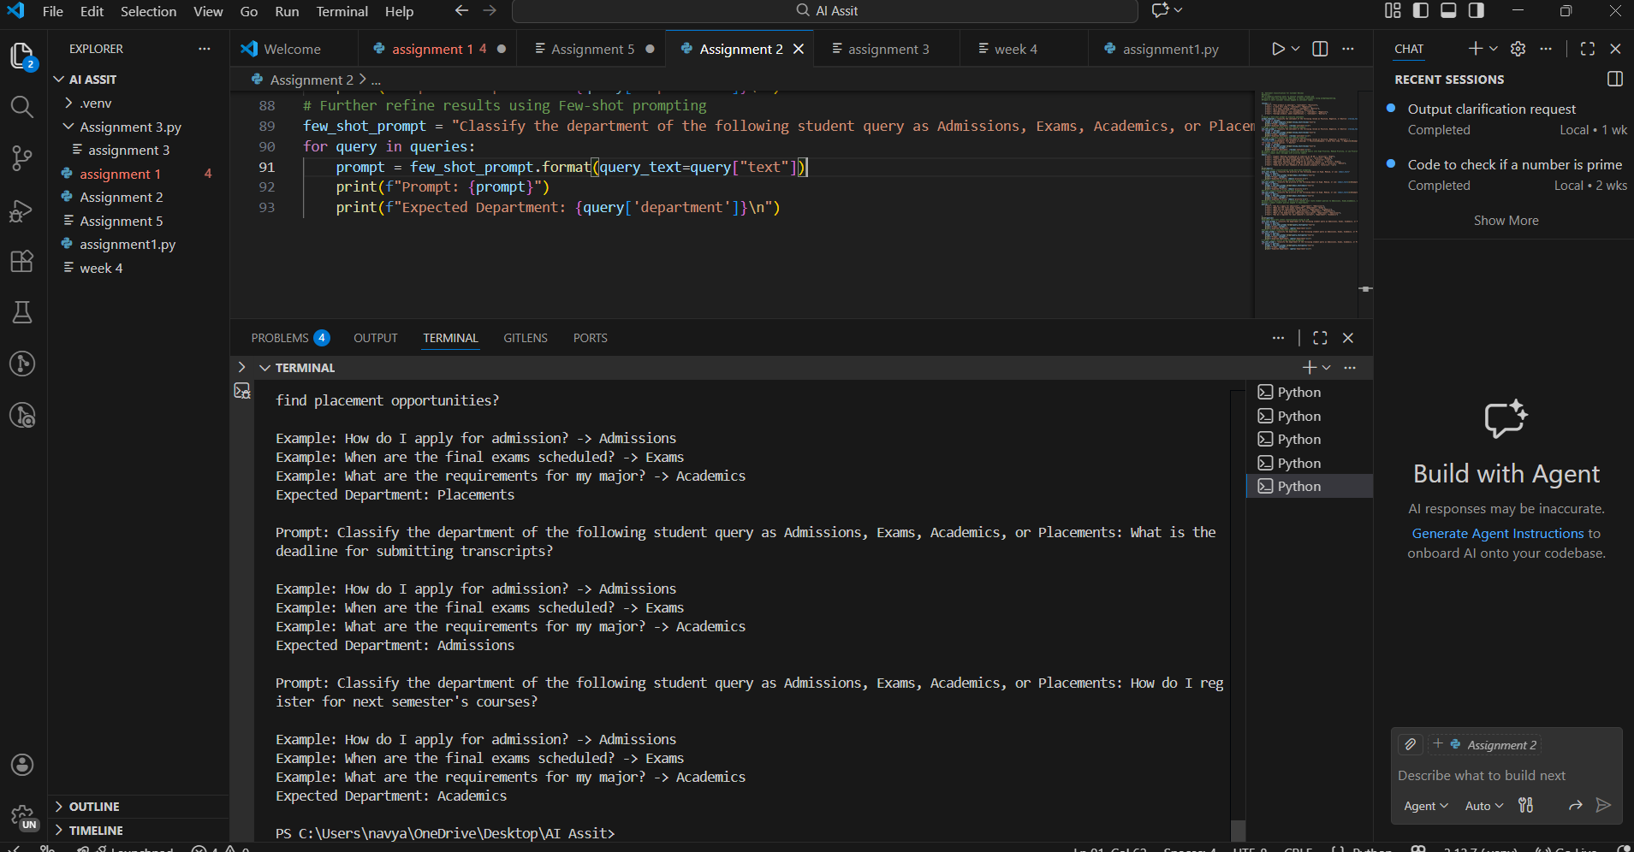Observation:
In few-shot prompting, multiple examples covering different departments are provided. This gives the model better context and a clearer understanding of intent boundaries. As a result, few-shot prompting produces more accurate and consistent department classification
Task 5:
Effect of Contextual Examples on Classification Accuracy
Contextual examples significantly improve classification accuracy in prompt-based intent classification.
- Without context (Zero-shot):
The model relies only on general language understanding, which can lead to misclassification when queries are ambiguous or similar across departments.
- With one example (One-shot):
Providing a single example gives the model a reference point, helping it better understand how queries map to departments, thus improving accuracy.
- With multiple examples (Few-shot):
Multiple contextual examples clearly define different intent categories and reduce ambiguity. This allows the model to recognize patterns more effectively, resulting in the highest and most consistent accuracy.
Conclusion
As the number of contextual examples increases, classification accuracy improves because the model gains clearer guidance on how to interpret and categorize inputs.
Question 4:
Task 1: Chatbot Question Type Detection. A chatbot must identify whether a user query is Informational, Transactional, Complaint, or Feedback. Prepare 6 chatbot queries mapped to question types.

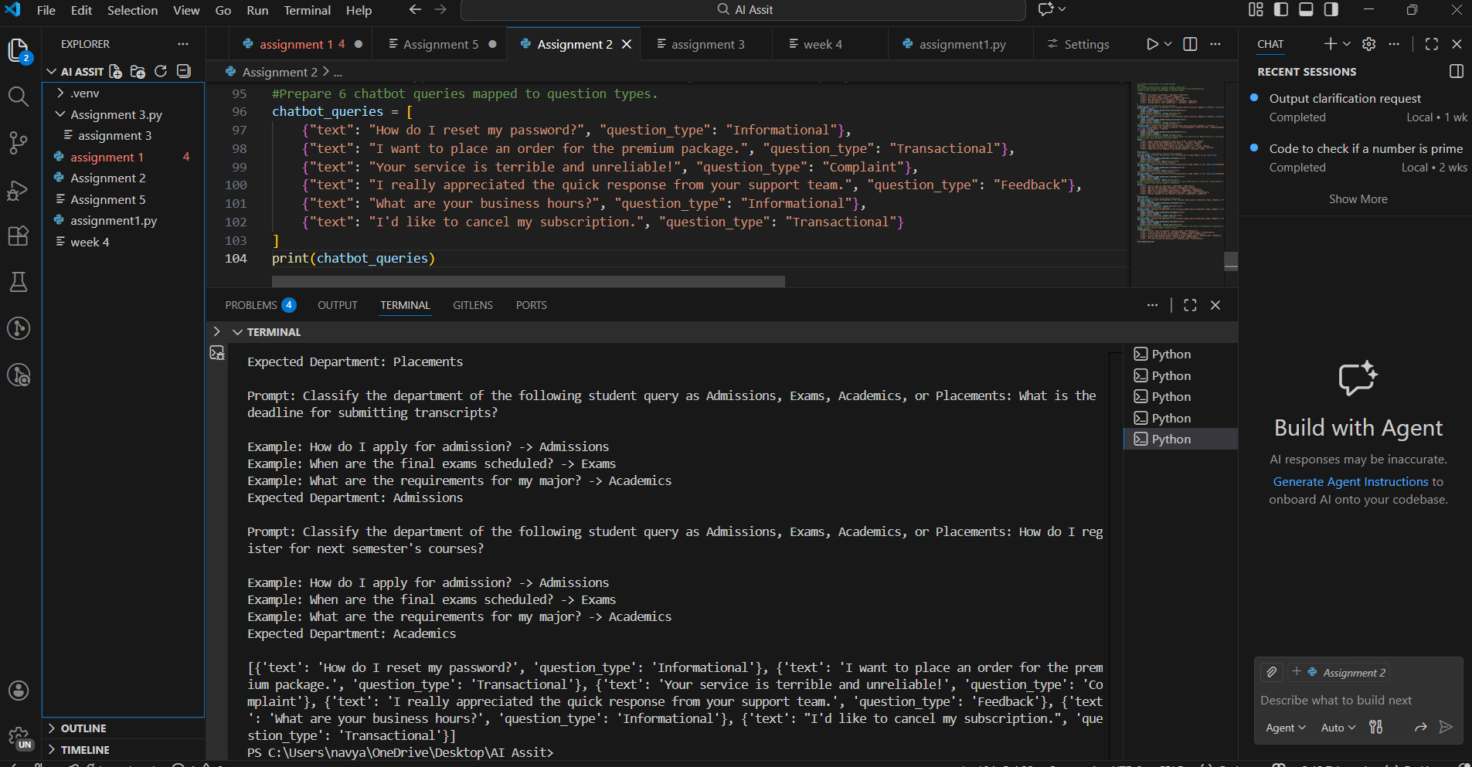
Task 2:
Prompt: "Classify the question type of the following chatbot query as Informational, Transactional, Complaint, or Feedback: {query text}"
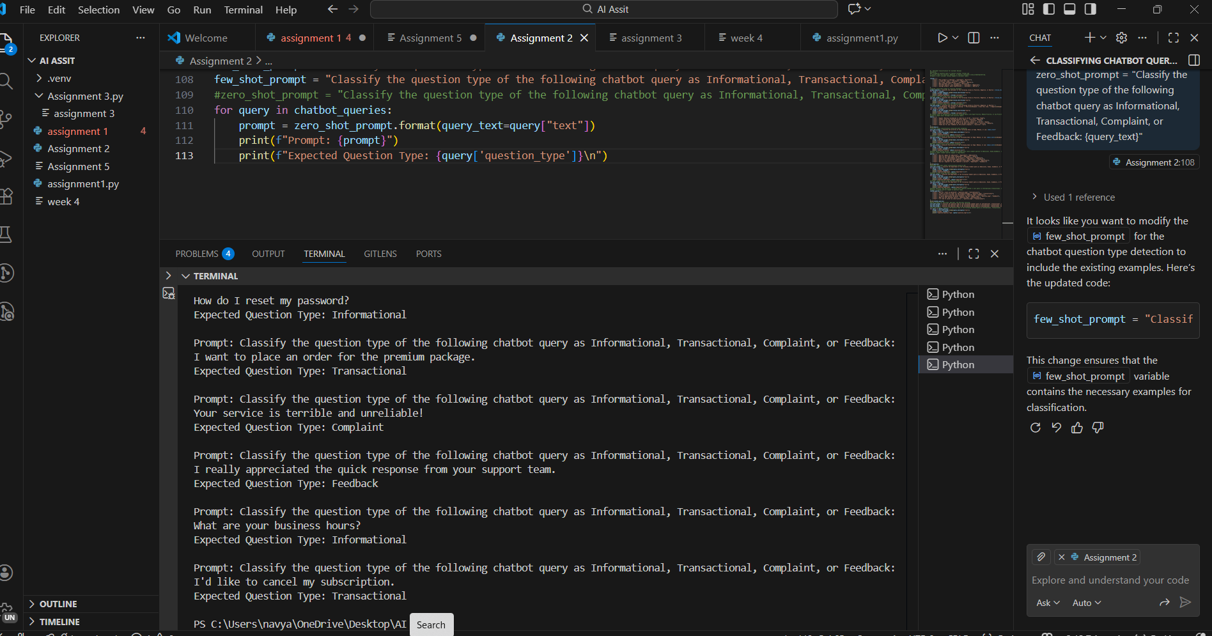
One shot prompt = "Classify the question type of the following chatbot query as Informational, Transactional, Complaint, or Feedback: {query text} \n\n Example: How do I reset my password? -> Informational"
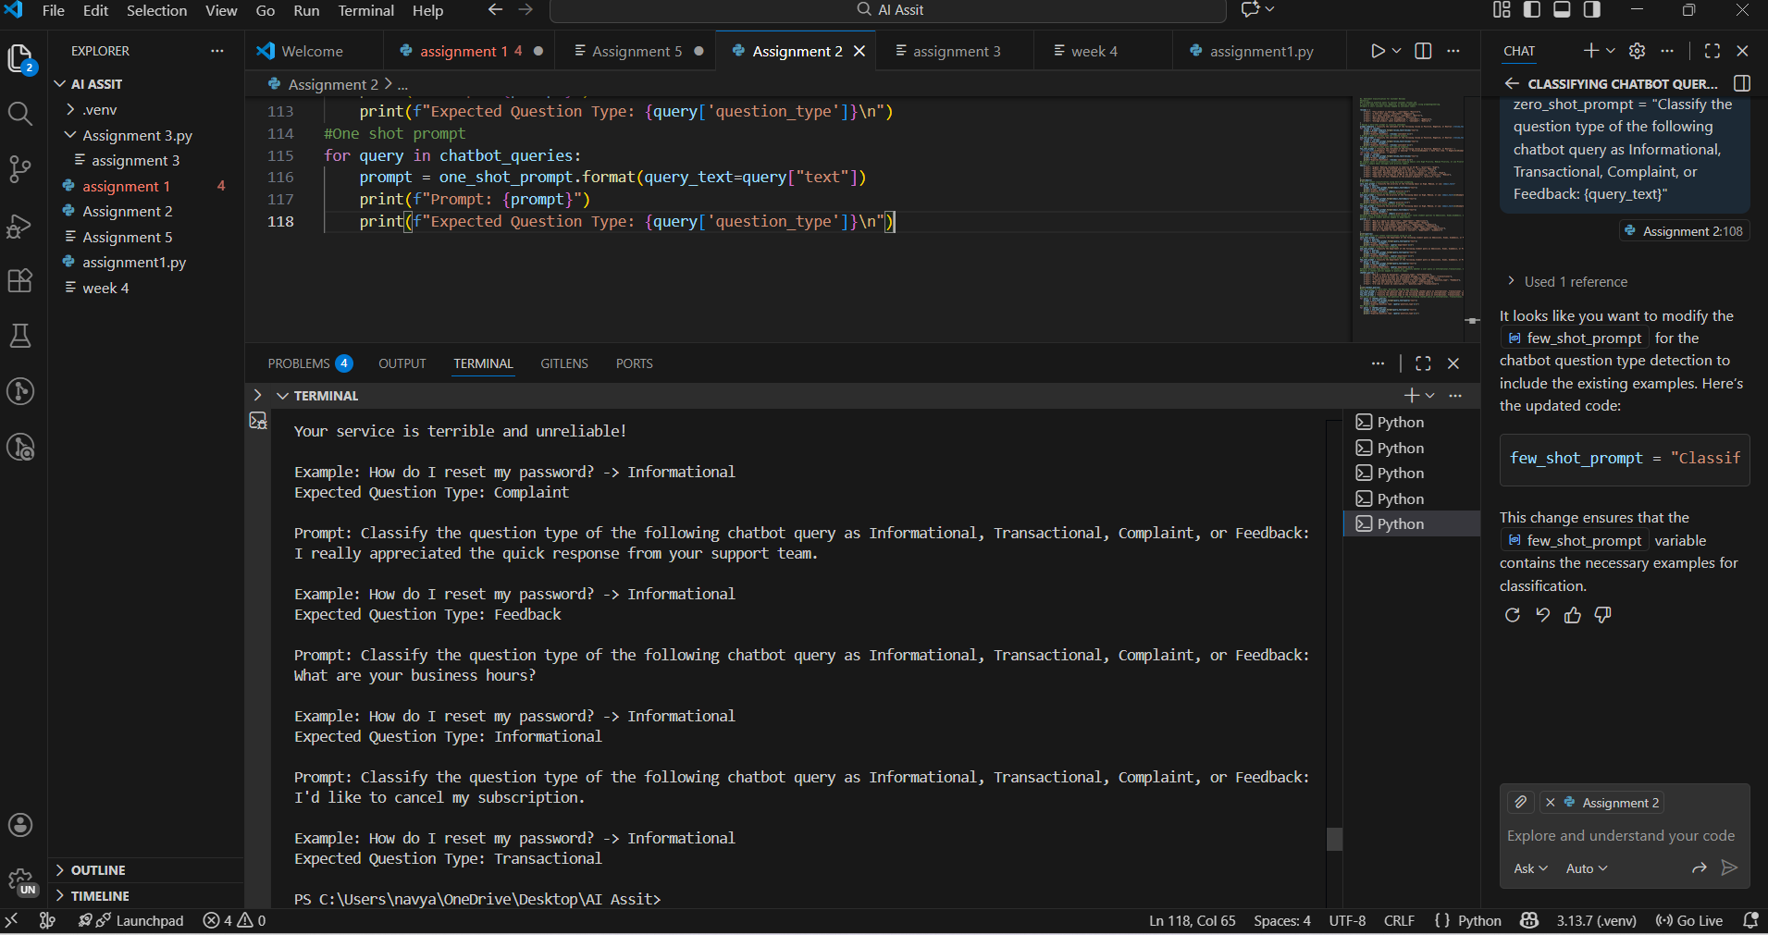
Few shot prompt = "Classify the question type of the following chatbot query as Informational, Transactional, Complaint, or Feedback: {query text} \n\n Example: How do I reset my password? -> Informational\n Example: I want to place an order for the premium package. -> Transactional\n Example: Your service is terrible and unreliable! -> Complaint"
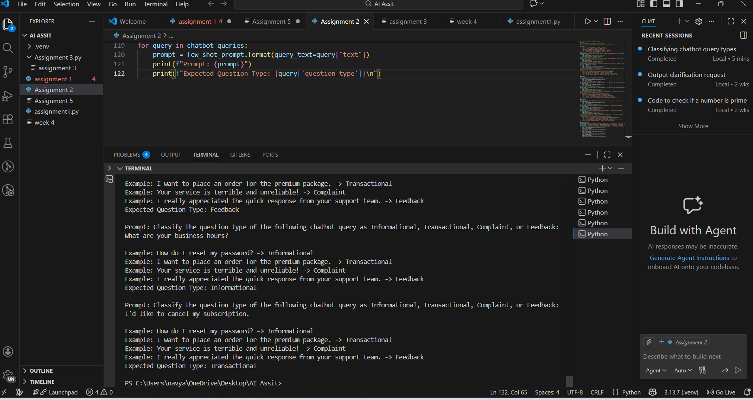
Observations – Chatbot Question Type Detection
- Zero-shot prompting works for clearly written queries but gives incorrect results for ambiguous queries.
- One-shot prompting improves accuracy by providing a single reference example.
- Few-shot prompting gives the most accurate and consistent classification.
- Few-shot prompting handles ambiguity better, especially between Complaint and Feedback.
- Increasing the number of contextual examples improves classification reliability.
Task 3: Testing on Unseen Queries
- Zero-shot prompting may confuse Transactional and Informational queries.
- One-shot prompting reduces confusion but still depends on similarity to the example.
- Few-shot prompting correctly classifies unseen queries in most cases.
- Few-shot prompting generalizes better to new inputs
Task 4: Comparison of Response Correctness and Ambiguity Handling
- Zero-shot Prompting:
Correct for clearly worded queries but struggled with ambiguous queries where intent was not explicit (e.g., complaint vs feedback).
- One-shot Prompting:
Improved correctness due to one example. However, ambiguity still existed when unseen queries were different in tone from the example.
- Few-shot Prompting:
Produced the most correct and consistent results. Multiple examples helped the model distinguish between similar intents like Complaint and Feedback.
Task 5: Zero-shot prompting has the lowest accuracy due to lack of contextual guidance.
One-shot prompting improves intent recognition but is limited by a single example.
Few-shot prompting provides the best accuracy and handles ambiguous queries effectively.
Contextual examples significantly reduce confusion between similar question types.
#Question 5:
Task 1:
Prompt
Emotion Detection in Text
Scenario:
A mental-health chatbot needs to detect emotions: Happy, Sad, Angry, Anxious, Neutral
Tasks:
*Create labeled emotion samples.
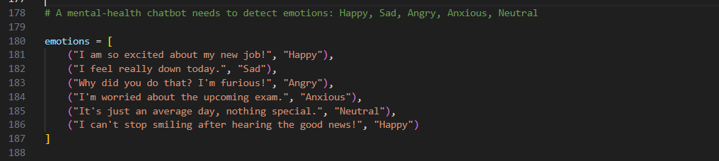
*Use Zero-shot prompting to identify emotions.
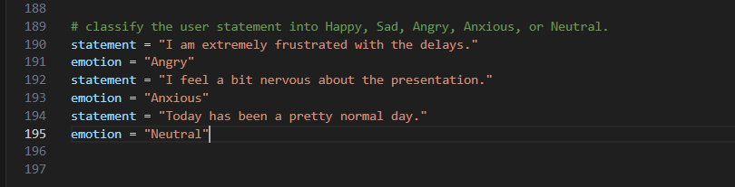
*Use One-shot prompting with an example
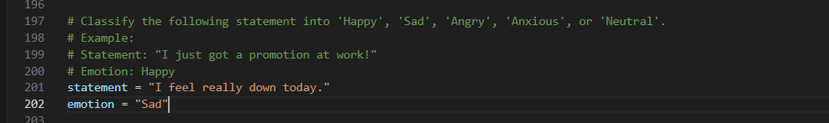
*Use Few-shot prompting with multiple emotions.
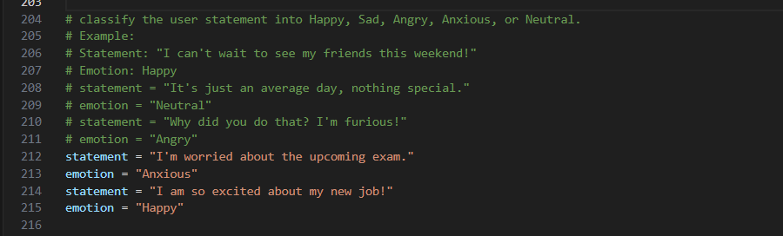
*Discuss ambiguity handling across techniques :
Few-shot prompting is expected to handle ambiguity better due to the presence of multiple examples that illustrate different emotional contexts. This helps the model learn subtle differences between similar emotions, such as Sad and Anxious. One-shot prompting provides some guidance but may not cover all nuances, leading to potential misclassifications in ambiguous cases. Zero-shot prompting relies solely on the model's pre-existing knowledge, which may not be sufficient for accurately distinguishing between closely related emotions, especially in complex or nuanced statements.

